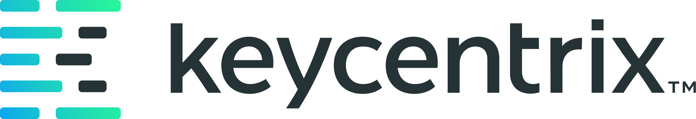
KCXDocumentor - Demo Script and Storyboard
Executive walkthrough script for the internal documentation workflow
Recipe alignment
Built as a keycentrix internal artifact using the DamienDev document recipe structure: control metadata, version history, purpose, scope, audience, governance, process detail, and appendices.

Metadata Field | Document Value
Document ID | KCXDOC-DEMO-001
Version | 1.0
Effective Date | 2026-06-05
Status | Internal demonstration ready
Owner | keycentrix Product and Training
Audience | Executive sponsors, product leadership, trainers, business analysts, and implementation leads
Build Standard | DamienDev document recipe

Document Control
Control | Value
Document Title | KCXDocumentor - Demo Script and Storyboard
Document ID | KCXDOC-DEMO-001
Status | Internal demonstration ready
Owner | keycentrix Product and Training
Audience | Executive sponsors, product leadership, trainers, business analysts, and implementation leads

Version History
Version | Date | Summary
1.0 | 2026-06-05 | Initial collateral package aligned to the DamienDev document recipe.

Purpose
Provide a concise 3 to 5 minute demo path that shows how KCXDocumentor turns a local recording into a reviewable Word guide.

Executive Summary
What this document is for
This file is part of the KCXDocumentor executive package and is intended to be readable as a standalone decision-support artifact.

Scope
Covers the recommended demo objective, production notes, storyboard, narration points, and close-out message for the executive review.

Intended Audience
Executive sponsors, product leadership, trainers, business analysts, and implementation leads

Governing Principles
- Keep raw recordings and local processing artifacts on the workstation.
- Send compact, reviewer-curated prompt context through the authenticated AI route.
- Keep human review in front of customer-facing publication.
- Track AI usage centrally by user, document, token count, page count, and estimated cost.

Demo Objective
- Show the working flow from imported recording to DOCX output.
- Emphasize local processing, authenticated AI access, reviewer control, and AI Spend visibility.
- Keep the demo centered on the documentation workflow rather than implementation details.

Production Notes
- Use a real source recording and show the import process.
- State that raw video stays local while compact reviewed context is sent through the authenticated AI route.
- Show frame approval and rejection because it is the primary quality gate.
- Close with the validation ask for trainers and business analysts.

Storyboard
Segment | Visual | Narration Focus
Opening | KCXDocumentor workspace | Recorded walkthroughs should not require hours of manual documentation work.
Import | Recording and transcript import controls | A reviewer imports the source recording and optional transcript.
Process | Processing progress state | Local media processing creates trace data and candidate screenshots.
Review | Frame reviewer | The reviewer rejects overlays and captures better screenshots when needed.
Create Guide | AI creation progress | Compact reviewed context is sent through the authenticated proxy.
Download | Download DOCX | The result is a Word guide ready for human review.
AI Spend | AI Spend page | Leadership can see documents, tokens, pages, costs, and user attribution.
Close | Validation summary | The next step is representative internal testing with BAs and trainers.

Close Message
- KCXDocumentor is ready for internal hands-on validation.
- The review should focus on output quality, screenshot relevance, reviewer workflow, cost per finished page, and readiness for a broader rollout.

